<https://chercher.tech/java/css-selector-selenium-webdriver>

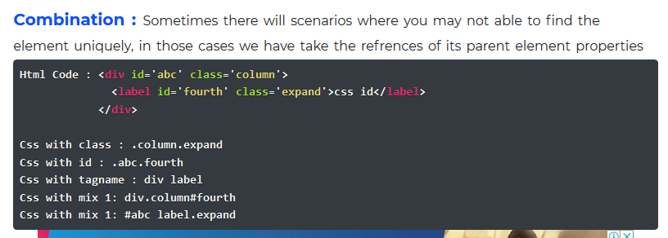

**CSS on the basis of ID**

Input#email (here input is a tag name and email is attribute name with **id** attribute type)

**CSS on the basis of class**

Input.email (here input is a tag name and email is attribute name with **class** attribute type)

**CSS on the basis of multiple attributes**

Input [class=’input’] [id=’email’]

**CSS using contains**

Input [id*=’login’] ( here ‘*’ is used for contains)

**CSS using starts with**

Input[id^=’login’]

CSS using ends with

Input[id$=’login’]

